AI Interview Room– Generative AI – Large Language Model

Project Description:
AI Interview Room is an adaptive technical interview platform powered by Generative AI and deterministic cognitive profiling. The platform conducts technical interviews dynamically rather than following a fixed question sequence. It evaluates candidate responses, maintains a multi-dimensional knowledge profile, and uses the evaluation results to determine the next question, difficulty level, and topic.
The system supports Gemini, OpenAI, and a Mock AI provider for local testing. It uses FastAPI for the backend, SQLite with SQLAlchemy for persistent storage, and HTML, CSS, and JavaScript for the frontend. Separate candidate and recruiter experiences are provided along with interview reports, analytics, question-bank functionality, and automated testing.

Scenarios
Scenario 1: A candidate starts a technical interview for a selected role and experience level. The system generates an initial question and records the candidate's response for evaluation.

Scenario 2: A candidate provides a strong answer. The evaluator identifies strong conceptual understanding, and the adaptive engine can move toward a deeper question, higher difficulty, or implementation-level topic.

Scenario 3: A candidate gives a partial answer. The system identifies missing or misunderstood concepts and generates a targeted probe to diagnose the gap before continuing.

Scenario 4: A candidate repeatedly struggles with a topic. The adaptive engine can select an easier question, run a diagnostic probe, or pivot to another topic while preserving the candidate's knowledge profile.

Technical Architecture:

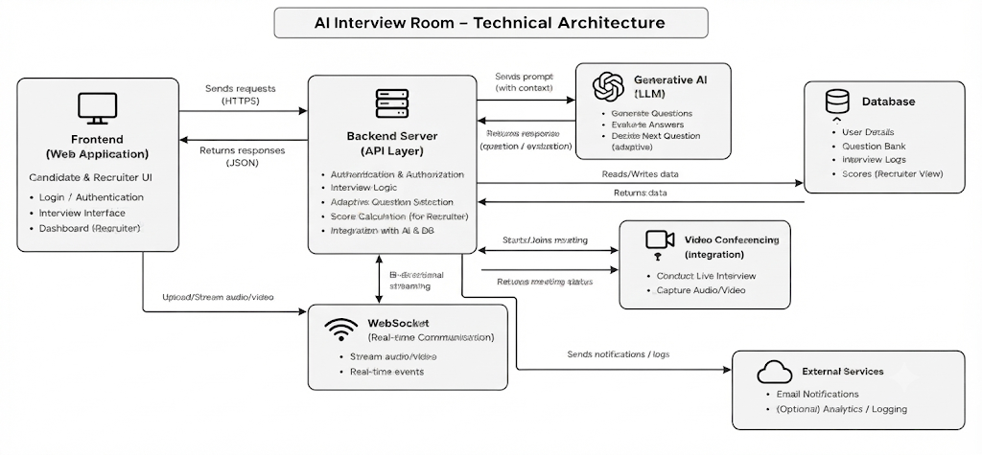

Pre-requisites:
- Python Programming Proficiency: Python Documentation
- FastAPI Framework Knowledge: FastAPI Documentation
- SQLAlchemy and SQLite Knowledge: SQLAlchemy and SQLite documentation
- Generative AI and LLM Concepts: Gemini/OpenAI API concepts
- HTML, CSS, and JavaScript Skills: Web frontend development fundamentals
- REST API Development: FastAPI request/response and JSON concepts
- Automated Testing with Pytest: Pytest testing fundamentals
- Development Environment Setup: Python virtual environment, pip, and .env configuration

Project Workflow:

Activity 1: Model Selection and Architecture
- Activity 1.1: Configure the AI provider environment and securely manage provider credentials.
- Activity 1.2: Select and configure the Generative AI provider used for interview question generation and answer evaluation.
- Activity 1.3: Define the adaptive interview architecture connecting the frontend, FastAPI backend, AI service, adaptive engine, and database.

Activity 2: Core Functionalities Development
- Activity 2.1: Implement adaptive technical question generation using role, experience, topic, difficulty, and previous-question context.
- Activity 2.2: Implement candidate-answer evaluation and multi-dimensional knowledge profiling.
- Activity 2.3: Implement adaptive decision-making for deeper questions, missing-concept probes, diagnostics, easier questions, topic pivots, and conclusion.

Activity 3: FastAPI Development
- Activity 3.1: Develop the FastAPI application, SQLAlchemy models, SQLite persistence, and Pydantic request/response validation.
- Activity 3.2: Implement interview start and answer-submission APIs and connect them to the adaptive engine.
- Activity 3.3: Implement candidate, recruiter, report, analytics, question-bank, and supporting API routes.

Activity 4: Frontend Development
- Activity 4.1: Develop candidate setup and interview configuration screens.
- Activity 4.2: Develop the live AI Interview Room with question display, answer input, progress, and submission workflow.
- Activity 4.3: Develop candidate dashboards and interview reports.
- Activity 4.4: Develop recruiter views and analytics.

Activity 5: Testing and Deployment
- Activity 5.1: Configure dependencies, environment variables, database initialization, and the application server.
- Activity 5.2: Run automated tests for adaptive decisions, API workflows, and interview progression.
- Activity 5.3: Validate depth-weighted scoring and knowledge-profile updates.

Activity 6: Conclusion

Milestone 1: Model Selection and Architecture
In this milestone, the project establishes the foundation for an adaptive technical interview platform. The design separates Generative AI responsibilities from deterministic interview progression logic so that AI-generated evaluations can be converted into controlled adaptive actions.

Activity 1.1: Configure the AI Provider Environment
Before the application can communicate with an external LLM provider, provider credentials and model configuration must be supplied through the project environment. The project supports Gemini and OpenAI, while a Mock AI provider is available for local development and testing without an external API key.
• Step 1 - Create the project environment and activate the virtual environment.
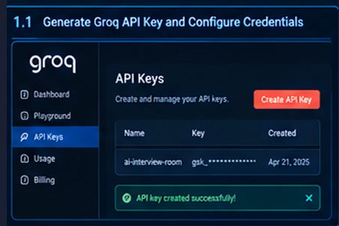
• Step 2 - Configure the selected provider and model through environment variables.
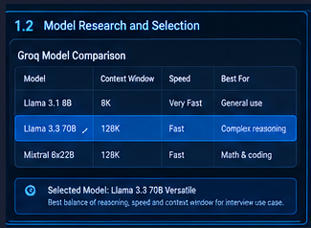

• Step 3 - Store API keys in the .env file rather than hard-coding secrets in application source files.
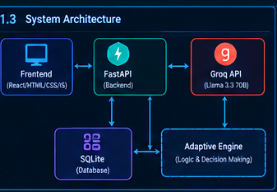

• Step 4 - Keep provider-specific integration behind the AI service layer so the interview workflow remains provider-independent.
AI_PROVIDER=mock
AI_MODEL=<configured-model>
AI_API_KEY=<provider-api-key>
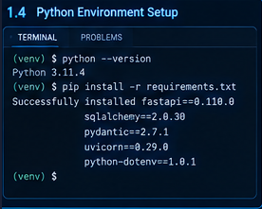

Activity 1.2: Select the Appropriate Generative AI Provider
The project requires an AI service capable of producing technical interview questions and evaluating candidate answers in a structured manner. Provider selection is based on compatibility with the application's prompts, structured evaluation requirements, response quality, latency, and development needs.
The project architecture supports Gemini and OpenAI as external providers and includes a Mock AI provider for local testing. This provider abstraction prevents the adaptive engine from being tightly coupled to one vendor.

Activity 1.3: Define the Architecture of the Application
The architecture connects the candidate interface to FastAPI endpoints. The backend creates interview sessions, generates questions, receives answers, invokes the AI evaluator, updates the knowledge profile, and calls the adaptive decision engine. Persistent interview information is stored through SQLAlchemy in SQLite.
• Frontend: HTML, CSS, and JavaScript candidate/recruiter interfaces.
• Backend: FastAPI routes, validation, session management, and application services.
• AI layer: Gemini, OpenAI, or Mock provider for question generation and answer evaluation.
• Adaptive engine: deterministic strategy selection based on evaluation and profile state.
• Data layer: SQLAlchemy models and SQLite database for persistent interview information.
Activity 1.4: Set Up the Development Environment
• Install a supported Python version and pip.
• Create and activate a virtual environment.
python -m venv env
env\Scripts\activate # Windows
source env/bin/activate # macOS/Linux
• Install project dependencies from requirements.txt.
pip install -r requirements.txt
• Configure the .env file for the selected AI provider and application settings.
• Verify that the SQLite database can be initialized by the backend.
• Prepare the frontend assets and backend application entry point.

Milestone 2: Core Functionalities Development
This milestone focuses on implementing the core functionalities of the AI Interview Room application. The system is developed to support AI-based interview question generation, interview interaction, response evaluation, feedback generation, and interview session management. The implemented functionalities are integrated with the backend services and database to provide a complete interview workflow.

Activity 2.1: Develop AI-Based Question Generation
Activity 2.1: Develop AI-Based Question Generation
The question-generation workflow creates questions dynamically from the candidate's interview configuration and current knowledge state. The generated question is influenced by the role, experience level, selected topics, current difficulty, target concept, and previously asked questions.
- Initial questions establish a baseline for the candidate's selected topic and difficulty.
- Previous questions are supplied as context so that the system can reduce unnecessary repetition.
- Adaptive actions can request deeper implementation details, trade-offs, edge cases, or targeted concepts.
- The generated question is returned to the frontend without exposing internal prompts or evaluation logic.

Activity 2.2: Implement Candidate Answer Evaluation and Knowledge Profiling
After a candidate submits an answer, the evaluation layer analyzes correctness and conceptual understanding. The evaluation result is normalized into fields that can be consumed by the deterministic adaptive engine.
- Score and correctness
- Understanding level
- Relevant demonstrated concepts
- Missing or misunderstood concepts
- Explanation and knowledge diagnosis
- Recommended next strategy
The knowledge profile tracks topic-level mastery, demonstrated concepts, missing concepts, attempt count, and current knowledge level. This profile becomes the persistent state used by later interview decisions.
Activity 2.3: Implement adaptive decision-making for deeper questions.

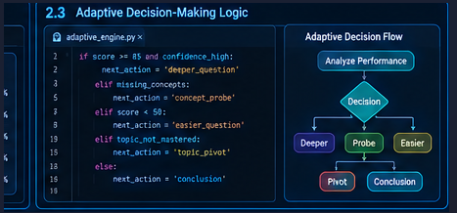

Milestone 3: FastAPI Backend Development
Milestone 3 focuses on implementing the FastAPI backend that coordinates interview sessions, AI services, adaptive decisions, database persistence, and reporting. The backend provides the controlled interface between the browser and the interview-processing services.

Activity 3.1: Implement the FastAPI Application and Database Integration
FastAPI provides the main application service. SQLAlchemy is used to define and access the SQLite persistence layer. Request and response structures are validated so that the frontend receives predictable JSON data.
- Initialize the FastAPI application and register project routes.
- Initialize SQLite database access and SQLAlchemy models.
- Persist candidates, interviews, questions, answers, knowledge profiles, and reports.
- Use validation schemas for API inputs and outputs.

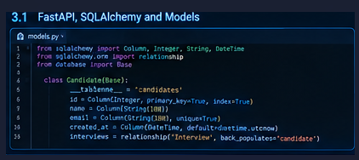

Activity 3.2: Implement Interview Session and Question-Answer APIs
The interview-start workflow registers or retrieves the candidate, applies the interview configuration, creates the interview session, initializes the knowledge profile, and generates the first question.
The answer-submission workflow receives the candidate response, evaluates it, updates the knowledge profile, runs the adaptive decision engine, stores the result, and returns the next question or a conclusion state.

Activity 3.3: Implement Reporting and Supporting APIs
Supporting routes provide candidate management, recruiter review, question-bank operations, analytics, notifications, interview history, and report retrieval. Recruiter-facing reports can include evaluation details that are not exposed in the candidate-facing interview room.

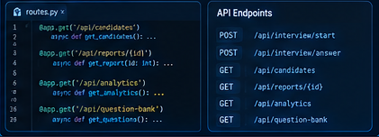
Adaptive Decision Logic
The deterministic adaptive layer translates evaluation evidence into controlled progression decisions. A strong response may lead to a deeper question; a partial response may trigger a missing-concept probe; and an incorrect response can trigger a diagnostic question before the system changes difficulty.
Depth-Weighted Scoring
The project uses difficulty-sensitive scoring so that performance on more advanced questions contributes more strongly to the depth-weighted score.
- Basic: 1.0× weight
- Intermediate: 1.5× weight
- Advanced: 2.2× weight
The system can therefore retain a raw performance measure while also producing a depth-weighted measure that reflects the level of questions successfully handled during the interview.

Milestone 4: Frontend Development
Milestone 4 focuses on building the candidate and recruiter web experiences using HTML, CSS, and JavaScript. The frontend communicates with FastAPI endpoints and presents only the information appropriate to the current user experience.

Activity 4.1: Candidate Setup and Interview Configuration
The candidate setup screen collects the information required to initialize an interview, including name, email, job role, experience, selected topics, and starting difficulty. The configuration is submitted to the backend before the live interview begins.
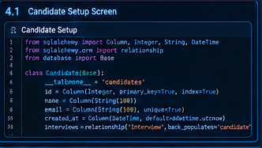

Activity 4.2: Live AI Interview Room
The live interview interface displays the current question, topic, difficulty, progress, answer input, and submission controls. Timers and transitions can be used to support a structured interview experience.Internal scores, adaptive decisions, prompts, and other recruiter-only evaluation details are not exposed in the candidate-facing interview room.

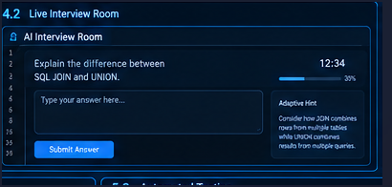

Activity 4.3: Candidate Dashboard and Interview Report
The candidate dashboard provides the interview workflow and access to the resulting report. The report can present performance scores, topic performance, difficulty breakdowns, demonstrated concepts, missing concepts, strengths, improvement areas, and the interview transcript.
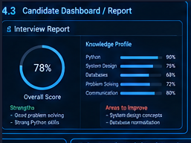

Activity 4.4: Recruiter Portal and Analytics
The recruiter interface provides access to candidate records, interview outcomes, detailed reports, the question bank, and aggregate analytics. These views are intended to support structured review of technical interview evidence.
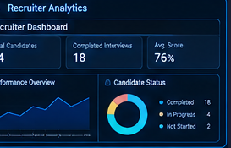

Milestone 5: Testing and Deployment
Milestone 5 focuses on validating the application locally, testing the adaptive interview logic, and verifying the complete flow from candidate onboarding to final reporting.

Activity 5.1: Preparing the Application for Local Deployment
• Create and activate the Python virtual environment.
• Install dependencies from requirements.txt.
• Configure the .env file for the selected AI provider.
• Verify SQLite initialization and application startup.
• Start the FastAPI development server using:
python -m uvicorn backend.main:app --reload --port 8000
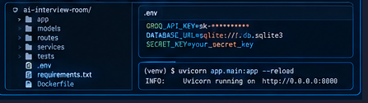

Activity 5.2: Automated Testing and Verification
Automated tests validate strong, partial, and incorrect candidate responses; repeated weak responses; difficulty progression; question repetition prevention; topic rotation; and complete interview API workflows.
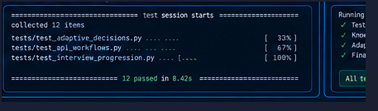
Activity 5.3: End-to-End Interview Validation
The end-to-end test covers candidate registration and configuration, question generation, answer submission, AI evaluation, knowledge-profile update, adaptive decision, next-question generation, interview conclusion, and report generation.
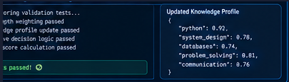

Exploring the Website’s Web Pages:

Candidate Setup / Interview Configuration Page:

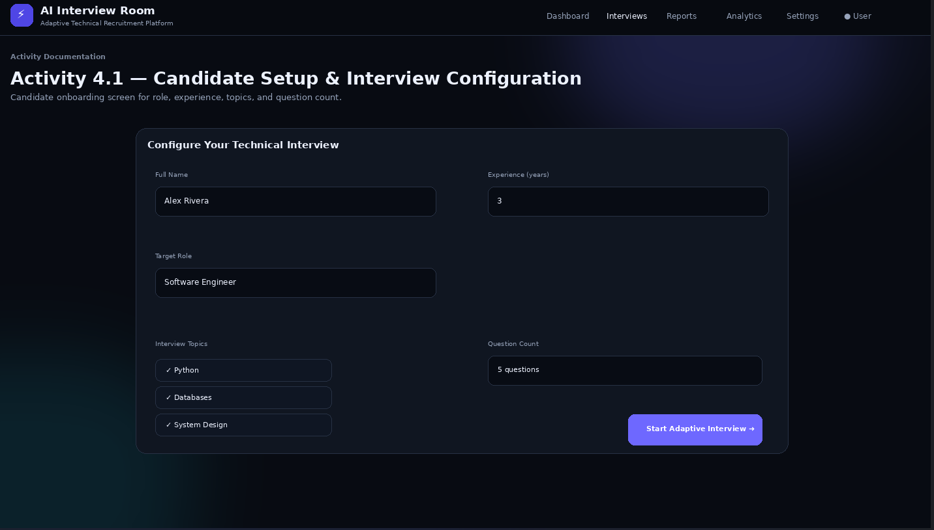

Description: The candidate configuration interface collects the candidate's basic information and interview preferences before the session begins. It provides fields for role, experience, topics, and starting difficulty and initiates the interview through the back end.

Live AI Interview Room:

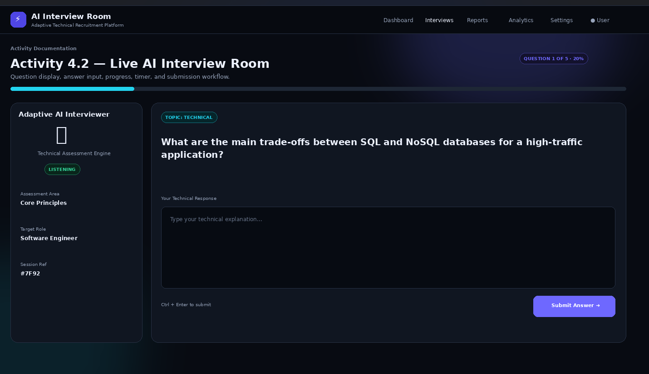

Description: The live interview page is the primary candidate workspace. It displays the current technical question, selected topic and difficulty, progress information, answer input, and controls for submitting the response. The interface is designed to keep the candidate focused on the current question while the adaptive processing occurs in the backend.

Candidate Dashboard:

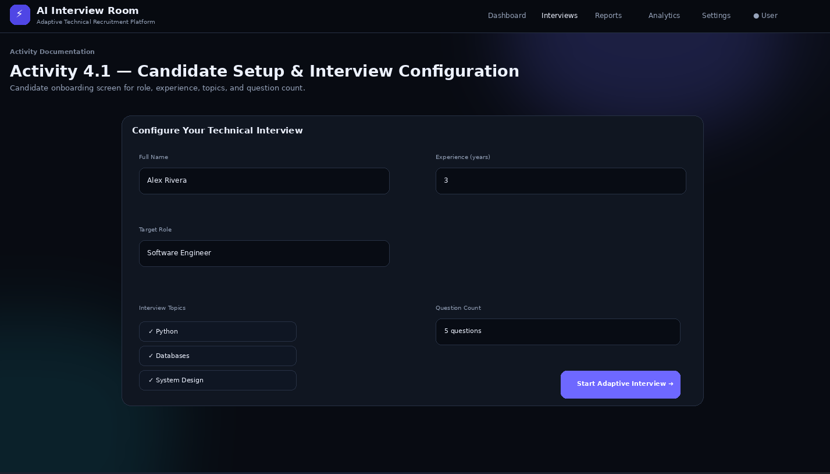

Description: The dashboard presents the candidate's interview workflow and provides access to completed interview information and the generated performance report.

Recruiter Dashboard:

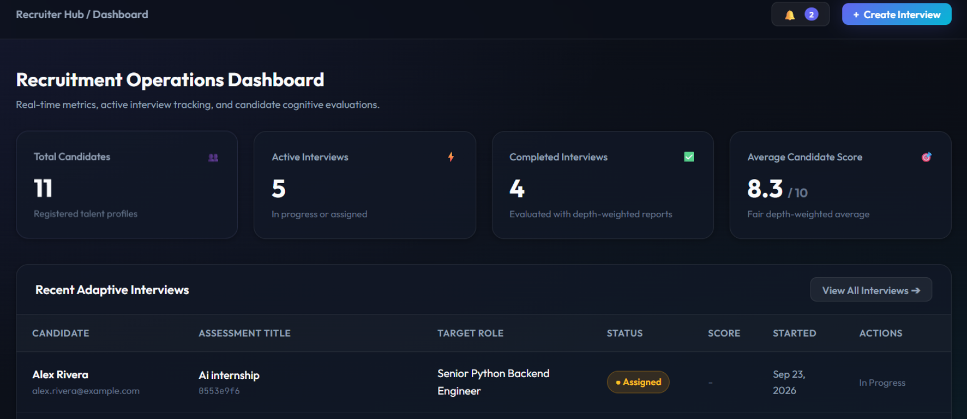

Description: The recruiter dashboard provides a consolidated view of candidates and completed interviews. Recruiters can navigate to candidate results, reports, question-bank content, and analytics.

Interview Performance Report:

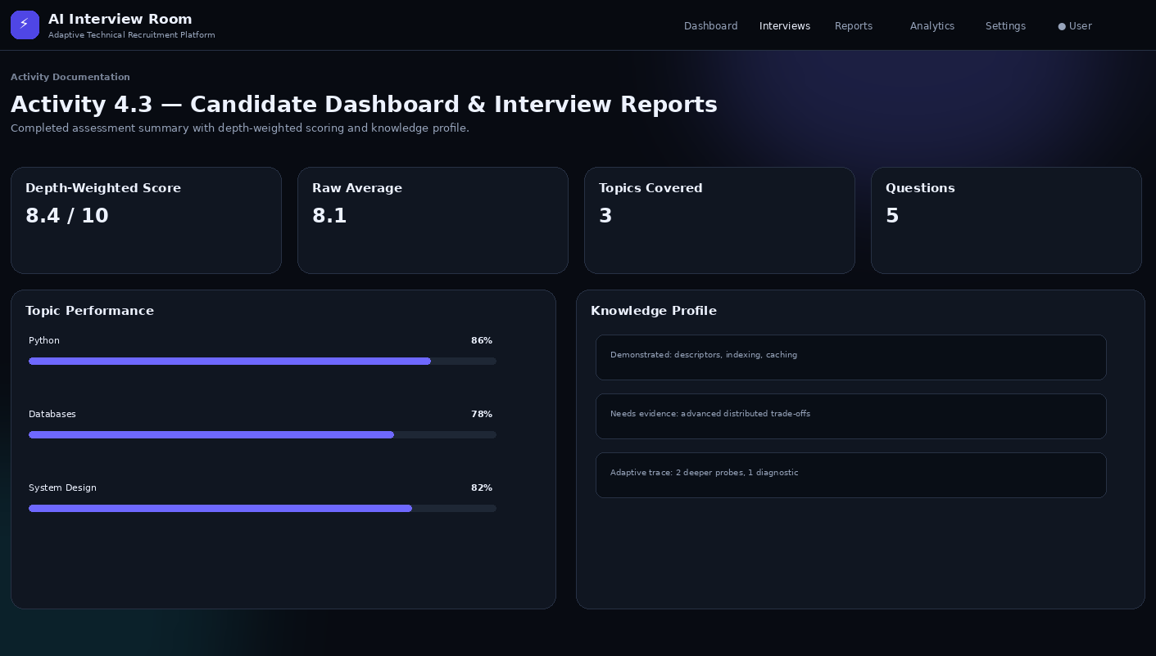
Description: The performance report summarizes the completed interview using overall and depth-weighted scores, topic and difficulty performance, demonstrated concepts, missing concepts, strengths, improvement areas, and transcript information.

Knowledge Profile:

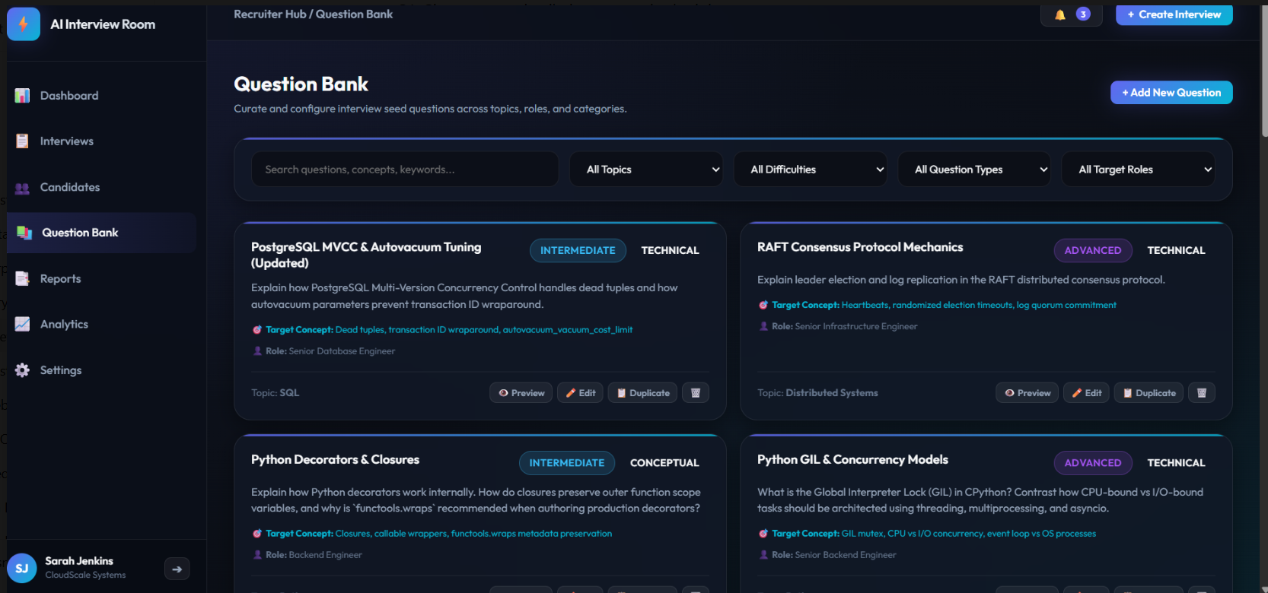
Description: The knowledge profile records the candidate's evolving mastery by topic, including demonstrated concepts, missing concepts, attempts, and knowledge level. It is used by the adaptive engine to select subsequent interview actions.

Interview Analytics:

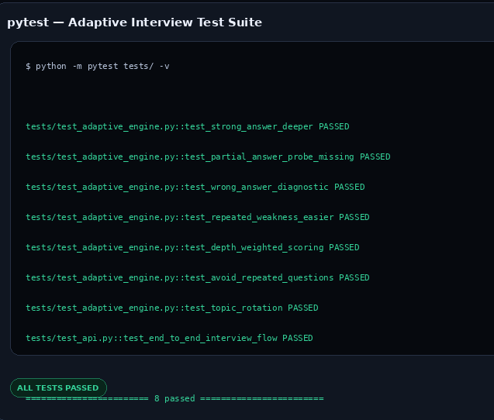

Description: The analytics interface aggregates interview information to provide a broader view of technical performance across candidates and interview sessions.

Conclusion:

AI Interview Room is an adaptive technical interview platform that combines Generative AI with deterministic decision logic and persistent knowledge profiling. Instead of following a fixed sequence of questions, the system uses candidate responses as evidence to determine the next topic, difficulty, and questioning strategy.
The platform supports strong, partial, and incorrect response scenarios through deeper questions, targeted probes, diagnostic questions, difficulty changes, topic pivots, and interview conclusion. Its knowledge profile records mastery information, demonstrated and missing concepts, attempts, and performance across difficulty levels. Depth-weighted scoring further represents the level of technical questions successfully handled.
The project integrates FastAPI, Python, SQLAlchemy, SQLite, configurable AI providers, HTML, CSS, JavaScript, and Pytest into a complete interview workflow covering candidate onboarding, live questioning, evaluation, adaptive progression, reporting, recruiter review, and analytics. The resulting architecture provides a structured foundation for AI-assisted technical interviewing while keeping the interview progression and stored evaluation data under controlled application logic.

